August 2022 – TCAP CCSESA Statewide Arts Initiative Newsletter

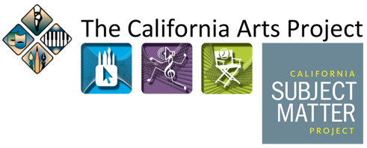

Collaborating to Build Statewide Awareness and Support Implementation California’s Arts Education Framework

TCAP is Looking Forward to Year 2 of the collaboration with CCSESA Statewide Arts, CCSESA’s Curriculum and Instructional Steering Committee, and the California Department of Education Initiative to support the California Arts Education Framework. In Year 1 the collaboration created and implemented a virtual Framework launch, Infographics and Handouts, a Framework slide deck, and a California Arts Education Framework Resources for Implementation hub. Additional resources to support awareness and implementation of the Framework will be created and shared in Year 2. Year 2 will kick off in the fall with a TCAP Leadership Practicum for county office leaders and TCAP leaders.

Upcoming 2022 – 2023 TCAP Professional Learning Opportunities!

TCAP's Regional Arts Education Network Communities (TCAP AEN’s) 2022 – 2023

TCAP’s Arts Education Networks will convene online once a quarter in 2022 – 2023 from 3:30 – 5:00 p.m. All virtual network sessions are free of charge but do require pre-registration. Registration will open soon on the TCAP website.

Dates:
September 22, 2022
November 17, 2022
February 23, 2023
May 18, 2023

TCAP’s statewide and regional networks support TK–12 through post-secondary dance, media arts, music, theatre, visual arts, and CTE AME educators as they strive to implement the goals of the Arts Education Framework and Standards to further equitable, standards-based arts education for California students.

The network sessions provide opportunities for teachers and administrators in the arts to stay informed of statewide and regional arts education news, issues, and dialogue with others on critical arts education topics.

New TCAP and Fresno State College of Arts and Humanities Webinar Series

Thriving Through the Arts: Supporting Arts Educators’ Well-Being and Social and Emotional Capacity

TCAP and Fresno State College of Arts and Humanities are collaborating on this new webinar series. Each webinar will feature a panel of therapists (art, drama, expressive arts, and dance movement) and be moderated by Dr. Kelvin Ramirez, a board-certified registered Art Therapist. All webinar sessions are free of charge and open to arts educators and college/university arts education students from across the state. Webinar sessions are projected to take place from 3:30 to 5:00 p.m. Pre-registration is required and will be open soon on the TCAP website.
Projected Dates
- October 27, 2022
- January 26, 2023
- February 16, 2023
- March 23, 2023

TCAP’s Arts Education Administrators and Leaders: Implementing Equitable and Effective Arts Education 2022 – 2023 Series

The 2020 CA Arts Education Framework illuminates the value and importance of providing equitable and effective arts education for all students. Revisiting and building upon last spring’s mini-series, new TCAP’s virtual series focuses on Chapter 9 of the Framework. The series will engage arts education leaders and administrators in conversation, sharing, and reflection. For administrators and leaders who missed Episodes 1 or 2 last spring, or would like to revisit, the episodes will be offered again this fall.
Register for one, multiple, or all series’ episodes. There is no cost, but pre-registration is required. Registration will open soon on the TCAP website.
Episode Times: 9:00 a.m. – 10:30 a.m.
Episode Dates and Topics
- Episode 1: Thursday, September 1, 2022 – Strategic Planning
- Episode 2: Thursday, October 6, 2022 – Professional Learning
- Episode 3: Date Pending – Curriculum Mapping
- Episode 4: Thursday, March 9 – Going Deeper into Strategic Planning
- Episode 5: Thursday, April 20 – Going Deeper into Professional Learning
- Episode 6: Date Pending – Going Deeper into Curriculum Mapping
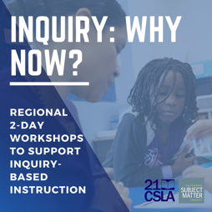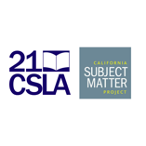 Inquiry: Why Now? Educational Leaders Workshop Summer Schedule
The California Arts Project along with our partners in the California Subject Matter Project and 21st Century California School Leadership Academy are hosting “Inquiry: Why Now?”

Educational leaders are invited to join this 2-day workshop series to explore how inquiry-based instruction fosters equity. This FREE workshop will address the following questions:
- What does inquiry-based learning look like?
- How do I support inquiry-based learning?
- How can I leverage inquiry-based learning to improve access, opportunity and inclusion for student populations who have historically been marginalized and underserved?
This workshop is designed for leaders in education and is tailored to support student needs in your region. Find out more and register today.

TCAP Customized Professional Learning Programs
Contact TCAP at reach.tcap@gmail.com to arrange or learn more about TCAP’s customized and context specific arts education professional learning programs for schools or districts.
Arts Education Resources on TCAP’s Website
The TCAP website has useful arts education information and resources for teachers, administrators, and arts education advocates. The Arts Education Resources website tab has a growing collection of resources including California Arts Education’s Framework and Standards, California’s Transformative Social and Emotional Learning (T-SEL), and resources related to safe school opening and arts education. Visit often, as the collections are updated.

The California Arts Project www.tcap.net
California Subject Matter Project – https://csmp.online
Facebook – The California Arts Project
Follow TCAP
Instagram – www.instagram.com/Tcapcalifornia
Twitter – www.twitter.com/tcapcalifornia

